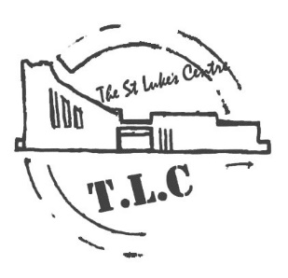
POP UP CAFÉ
THURSDAY 13th SEPTEMBER
12.30pm – 1.30pm
Chilli Con Carne or Veggie Chilli
£3.90
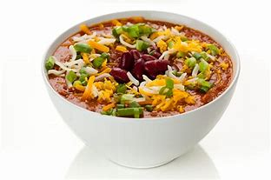

ST Lukes Church , Guidepost Road , Longsight M13 9HP
0161 273 1538

