Summary: Of the 71 surveys sent out 65 were returned, which is an 91.54% return rate. The results here are based on the responses received. However, there are cases where some questions were skipped and or went unanswered. The 65 people who returned the survey will each receive a £20 Asda gift voucher in December 2020.

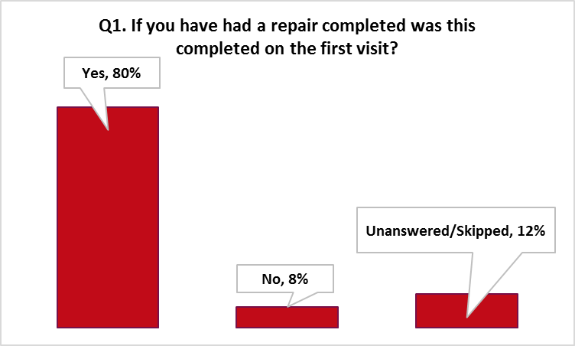
- Introduction: Arawak Walton is committed to ensuring that residents can give their views and take part in the decision-making process in a way that fits with their lifestyle and commitment. The purpose of this survey on ‘Repairs and Maintenance is to It look at the role of the Association and understand how best we can support our tenants and improve on our services.

  - We asked the question, “If you have had a repair completed was this completed on the first visit?” The vast majority (80%) said “Yes”, (8%) responded “No” and the remaining (12%) either skipped or did not answer the question.

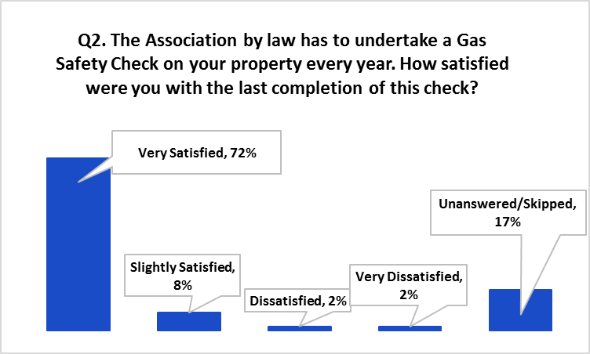
  - We said “The Association by law has to undertake a Gas Safety Check on your property every year. How satisfied were you with the last completion of this check?’ The bulk of the responses (72%) agreed that they were ‘Very Satisfied’ with the gas safety check that was carried out in their property, whilst a handful (8%) said they were only ‘Slightly Satisfied’. An extremely small percentage (2%) said they were ‘Dissatisfied’ and the same count (2%) for ‘Very Dissatisfied’. The question was skipped or remained unanswered by (17%) of the responders.

  - “We said ‘In your experience, when requesting a repair, has an appointment been arranged for someone to attend? The largest portion of tenant replies (85%) said “Yes” an appointment had been arranged for someone to attend; with only (8%) who stated “No” and (3%) who said ‘Sometimes’. Again, the question was skipped or remained unanswered by (5%) of the returns.

  - Following on from Question 3, we then asked you, “Having been given an appointment for your repair, has the appointment always been kept? Over (82%) of tenants responded by saying “Yes”, (9%) remarked “No” and a small fraction (3%) selected ‘Sometimes.’ The remaining (6%) skipped or failed to answer the question.

  - As a tenant, how easy do you find it to communicate with the Association before and after your repair has been carried out? Of the returns received (71%) advised that it is ‘Very Easy’, whilst (25%) advised it as ‘Fairly Easy. A small portion (2%) regrettably, found it ‘Fairly Difficult’, there were no votes for ‘Very Difficult’. The remaining (2%) missed or failed to answer the question.

  - During the pandemic we have asked you to send in pictures and video to help us diagnose problems. How comfortable are you with sending us information in these ways? See table below which shows a mixed result for all the formats we put to the residents. The table displayed below establishes that tenants favour reporting by telephone as their top choice.

Format | Very Comfortable | Comfortable | Uncomfortable
Telephone | 34 | 21 | 1
Pictures | 15 | 13 | 9
Video | 11 | 11 | 11

1.7 The Association aims to paint the exterior of your property every 6 years; what did you think of the quality of the work the last time it was carried out? Disappointingly (31%) of the respondents stated they found the quality of the work ‘Poor’, (23%) selected for ‘Very Good’; some residents said the painting is ‘Fairly Good’ by (18%), ‘Good’ by (14%) and (14%) of the returns missed or skipped the question.

2.0 | SUMMARY and ACTIONS
2.1 | You tell us that there is a good culture of using the service, making and keeping appointments and of getting repairs completed on the first visit. We will continue to monitor this to maintain these standards.
2.2 | The vast majority of you are comfortable with the use of telephone and sending pictures to diagnose repairs and we will continue to expand this. The use of video is less popular so we will keep this under review.
2.3 | A significant number (31%) were dissatisfied with the standard of the cyclical painting at your homes. We will put stronger monitoring in place for the coming programme to more closely assess the quality of the work.

Thank you for taking the time to complete Postal Survey 4 – Repairs and Maintenance
May we take this opportunity to wish you a peaceful, joyous Christmas
Keep Safe

