Summary: Of the 1125 surveys sent out 89 were returned, which is an 7.91% return rate. The results here are based on those responses received, however, there are cases where some questions were skipped and/or went unanswered.

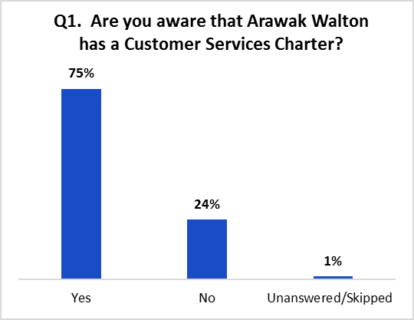
1.0 Introduction: Arawak Walton is committed to ensuring that residents are able to give their views and take part in the decision-making process in a way that fits with their lifestyle and commitment. The survey was carried out by means of a questionnaire, consisting of enquiries on our Customer Service Charter, which was also available to complete online.

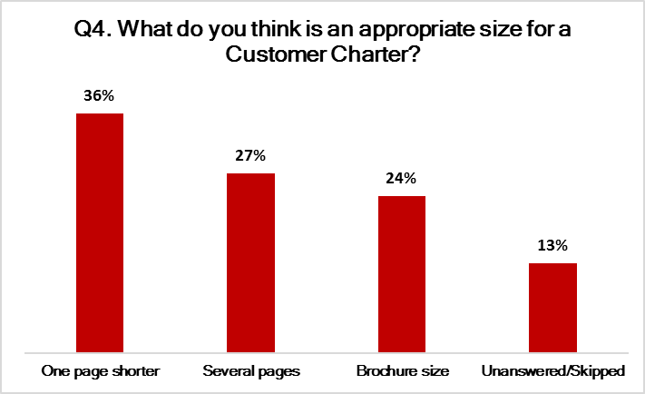
  - In Question 1, we asked “Are you aware that Arawak Walton has a Customer Service Charter?” (Please tick one). Of the sample responses returned the vast majority (75%) indicated that they are aware of the Arawak Walton Customer Service Charter which is reassuring. However, disappointingly, (24%) said ‘No’ and the remaining replies (1%) either skipped or did not answer the question.

  - In Question 2, which follows on from the previous question, we said, “If yes, how familiar are you with its contents?” Please tick one. Of the replies received (39%) responded ‘Fairly familiar’; ‘Unfamiliar’ at (18%) ‘Not very informed’ (15%) ‘Very familiar’ (13%) and ‘N/A (not applicable) at (4%). The remaining (10%) skipped or did not answer the question.

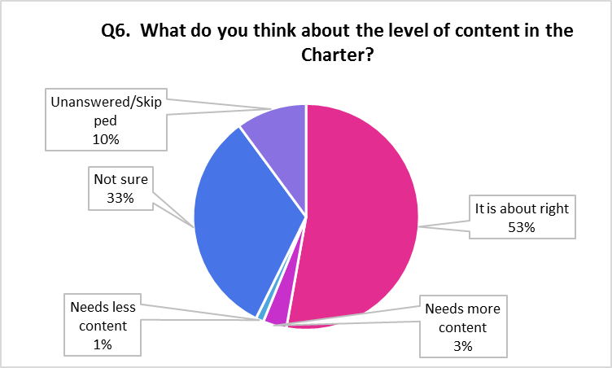
  - In Question 3 we said, “Do you think The Customer Service Charter is useful to you as a tenant?” (Please tick one). The responses received, (42%) thought ‘Yes, it is extremely useful’; (27%) selected ‘’Occasionally it is of use’; (13%) said ‘I don’t understand it’; (11%) stated ‘No, it is of no use to me’ and (7%) left the question unanswered or it was skipped.

  - Question 4 we asked you “What do you think is an appropriate size for a Customer Charter?” (Tick one). We recorded a response rate of (36%) who opted for ‘One page shorter’; (27%) ‘Several pages’; (24%) ‘Brochure size’ and again (13%) of the responders failed to answer or chose to skip the question.

  - In Question 5 we asked you “How would you like to receive updates about any changes to the Charter?” (Please tick all that apply). The number of votes from tenants that favoured to receive updates by post was 35; the choice for changes to be ‘Included in a Newsletter’ was 33; a low 16 votes was preferred ‘As part of the Annual Report’; whereas 14 nominated ‘On the website’.

  - In Question 6 we said, “What do you think about the level of content in the Charter?” (Please tick one). Over half of the responses received (53%) believe ‘It is about right’; (33%) were ‘Not sure’; (3%) said ‘Needs more content’; (1%) ‘Less content’ and (10%) skipped or left the question unanswered. Only methods suited to the tenant were selected leaving some suggestions skipped or left unanswered.
  - The table below displays your responses to Question 7 where we asked you “By what methods would you like to communicate with the Association?” (Please tick all that apply).

Method of Communication | Votes | Method of Communication | Votes
Telephone | 64 | Text Phone | 6
In Person | 29 | Face Time | 2
Text Message | 33 | Social Media | 2
Email | 29 | Interpreter | 1

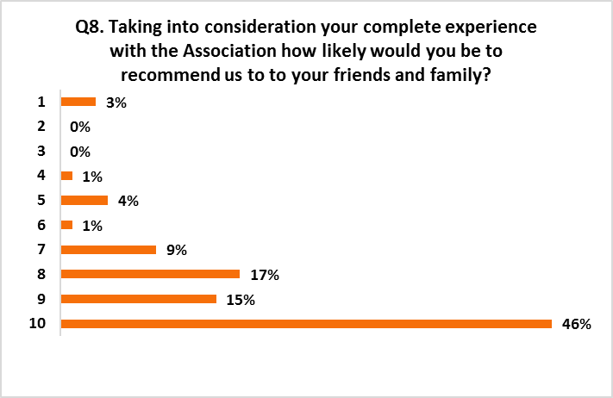
  - Using the scale of 1 for ‘Very Unlikely’ and 10 for ‘Very Likely’ we asked you in Question 8 “Taking into consideration your complete experience with the Association how likely would you be to recommend us to your friends or family? (Please Tick one). Of the responses received only (3%) skipped or did not answer the question but either way, as displayed in the graph just under half of the responses said they would ‘Very Likely, recommend the Association which is encouraging to see.

2.0 | SUMMARY
2.1 | We acknowledge that the return rate for this survey is extremely low compared to previous years. As a result, we cannot take it as a broad representation of tenants’ views. It is highly likely that the low return rate relates to the disruption caused by the COVID19 pandemic and the upheaval it has brought to peoples’ regular routines. For this reason, we are considering circulating the second survey to all of our tenants who completed the first survey in 2019 as well as those who returned this one.
2.2 | From the information we have been able to gather the key patterns are as follows:  - Overall a high percentage of participates felt the Charter is a little too long.  - We should use the Newsletter as a mechanism to advertise and consult on any changes to the charter.  - It demonstrates that many tenants continue to prefer contacting us by telephone.

  - The remaining (3%) skipped or did not answer the question.

ACTIONS

As a result of the information provided from the returned surveys, we plan to revisit the Charter to analyse if it can be reduced in size to some degree. We do not want to detract from the content, but it may be possible to convey the information in a more concise manner. If we are able to make these changes, we will promote them in our Newsletter.

Thank you for taking the time to complete Postal Survey 1 - Customer Service Charter 2020
Keep Safe

